History of Pauls Valley

The county seat of Garvin County, Oklahoma, Pauls Valley is located near the Interstate 35 juncture with State Highway 19, fifty-seven miles south of Oklahoma City in the heart of the fertile Washita River agricultural complex. Corn, wheat, hay, and cotton have been grown successfully in the region. With abundant feed, available, cattle production is a major activity. Pauls Valley also hosts businesses catering to the petroleum industry, which is secondary to agriculture in the town's economic base. In recent years, the community has diversified its economy by recruiting manufacturers of plastics and other products.

Pauls Valley was settled by Smith Paul, a North Carolinian and an intermarried citizen of the Chickasaw Nation. At the confluence of Rush Creek and the Washita River he established a plantation-sized farm shortly before the Civil War. Soon, "Smith Paul's Large Farm" was a location to which mail was often addressed. After the war Paul was appointed agent for the remnant bands of Indian refugees in the Rush Creek valley. His estate, known as "Smith Paul's Reservation," was a mail stop on a trail established by Comanche and Kiowa Indians as a route from Boggy Depot to Fort Sill. Official recognition as a postal office came in 1871 with the designation as "Paul's Valley, Arkansas," a misnomer occasioned by the fact that Indian Territory was then administered from the Western District of Arkansas.

In 1887 the Atchison, Topeka and Santa Fe Railway completed its line from Kansas to the Gulf Coast, passing through the Rush Creek valley. Tecumseh McClure, Paul's stepson, controlled the land around the original town site and did not want a depot there. Sam Paul, Paul's son, granted the railroad land for a station one mile north of the settlement, with the provision that the depot be named "Smith Paul's Valley." However, the name was too long for the station sign and was shortened to "Paul's Valley," which was later corrupted to "Pauls Valley."

As incorporation of cities was against the laws of the Chickasaw Nation, Sam Paul had town lots platted near the depot and, through a "town site company," sold patents to lots fronting the railroad. Merchants, advantaged by the railroad's capacity for quickly transporting goods to and from eastern markets, turned the community into a marketing center.

By 1890 Pauls Valley's population had grown to 396 people. Selection as a site for the U.S. Commissioner's Court in 1895 strengthened the town, and in 1898 the population reached 1,407. The 1887 town plat was approved by the Dawes Commission in 1903. Pauls Valley wrested status as county seat from competitors during 1907 statehood elections when floodwaters prevented opposition voters from reaching ballot boxes. At statehood Pauls Valley's population was 2,157. By 1930 that number had reached 4,232. Since 1960 the population has remained nearly constant, fluctuating between 5,500 and 6,800 people. There were 6,256 residents in 2000 and 6,187 in 2010. At the turn of the twenty-first century three Pauls Valley properties were listed in the National Register of Historic Places: the Garvin County Courthouse (NR 85002758), the Santa Fe Depot (NR 85003651), and the Pauls Valley Historic District (NR 79001993). (Michael Tower, "Pauls Valley," The Encyclopedia of Oklahoma History and Culture, www.okhistory.org)

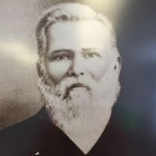
.Smith Paul
(http://paulsvalley.com)

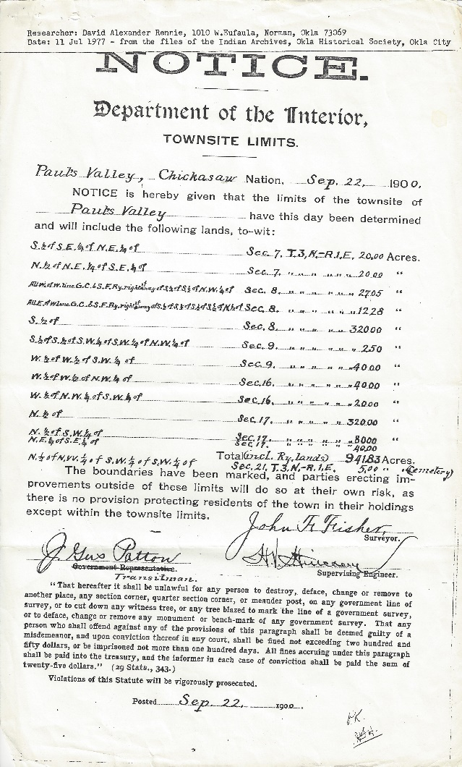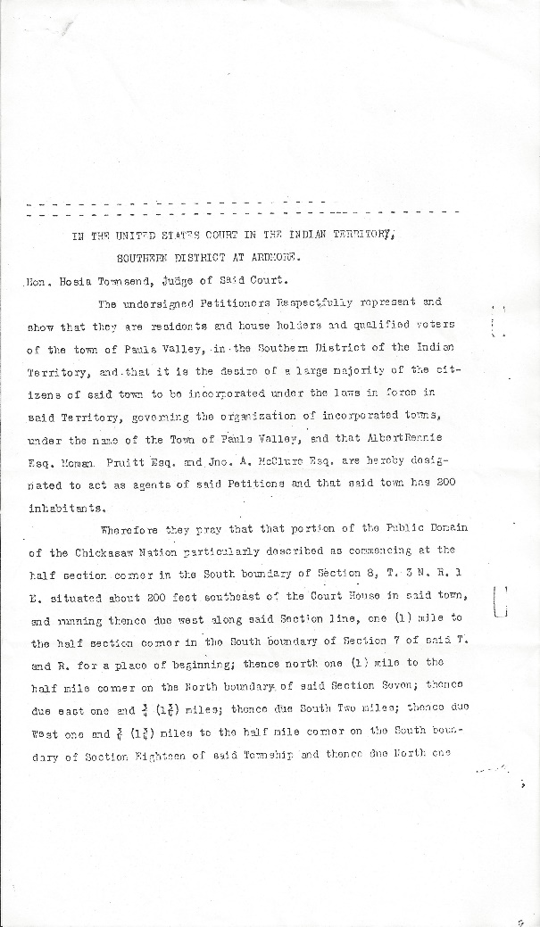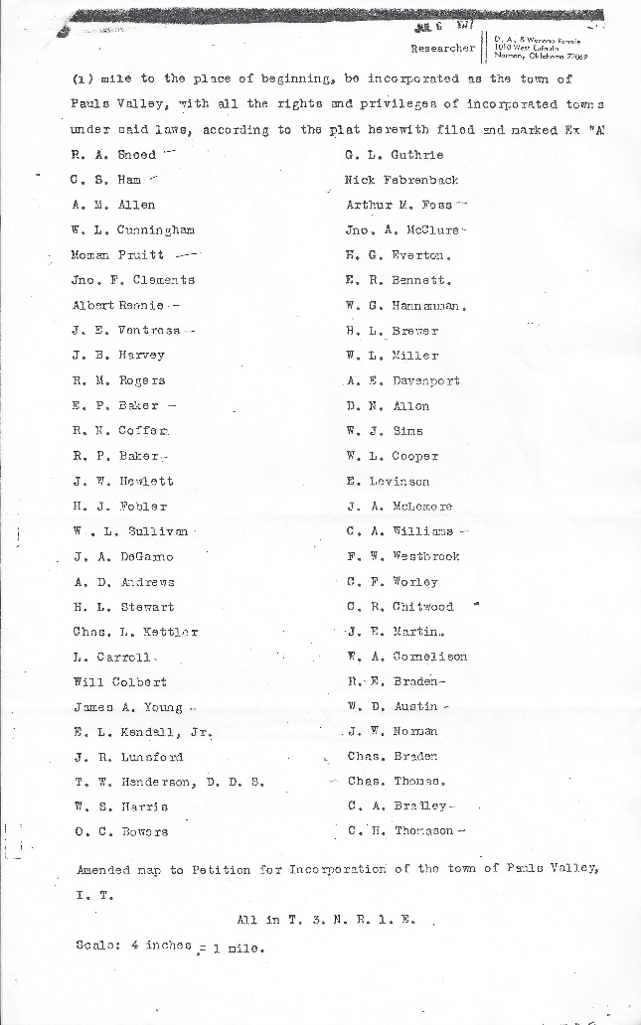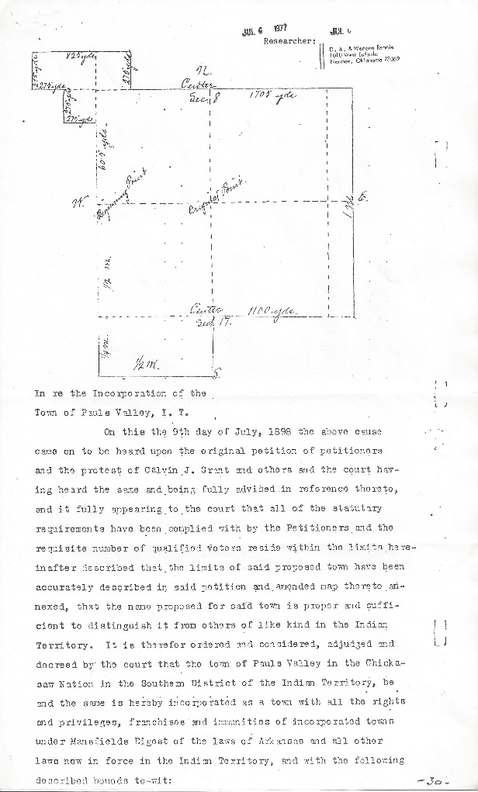
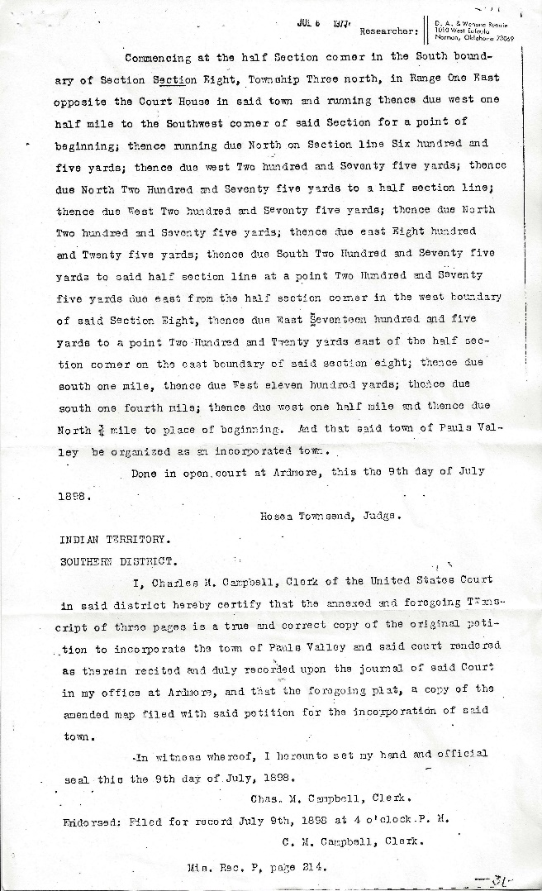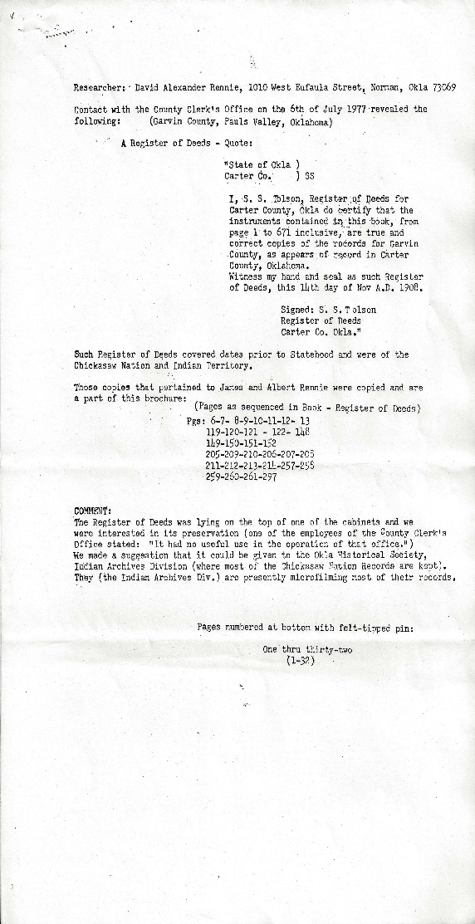
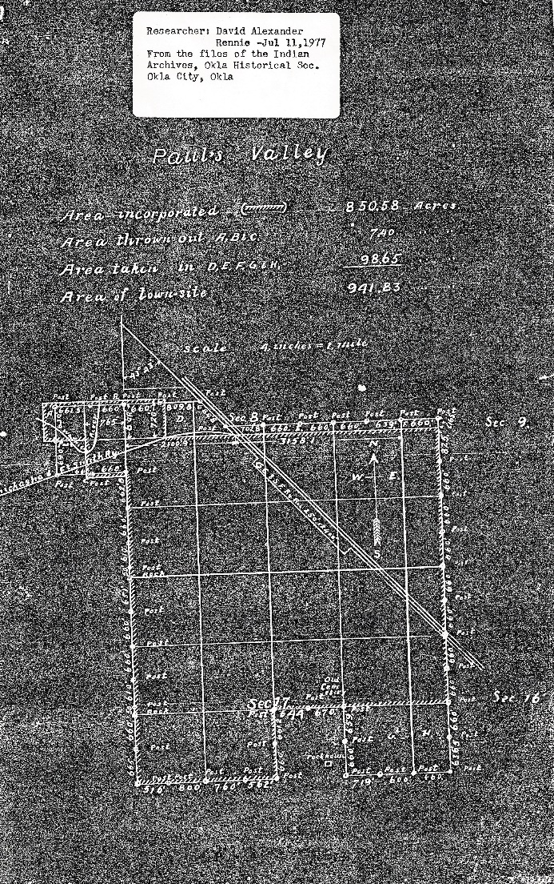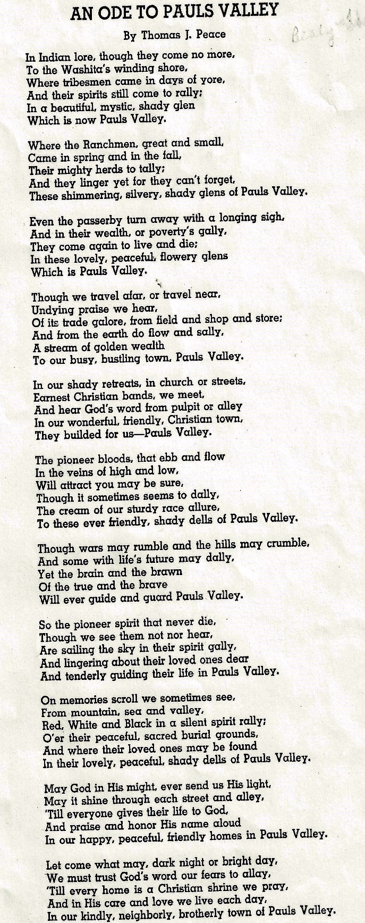
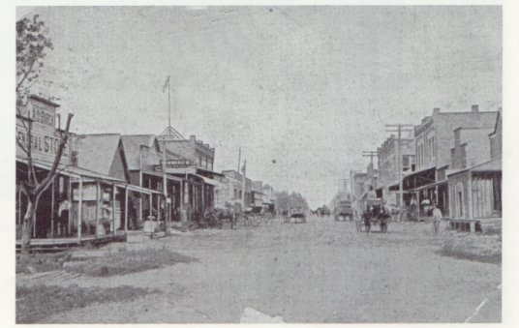
This is a view of Chickasaw Street looking North, Pauls Valley, Indian Territory
(http://okgenweb.net/~okgarvin/towns/pvhistory.htm)

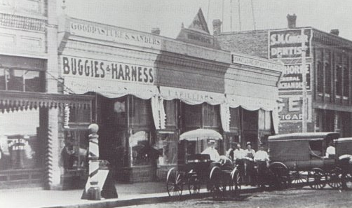
Early 1900's street scene in Pauls Valley
(http://okgenweb.net/~okgarvin/towns/pvhistory.htm)

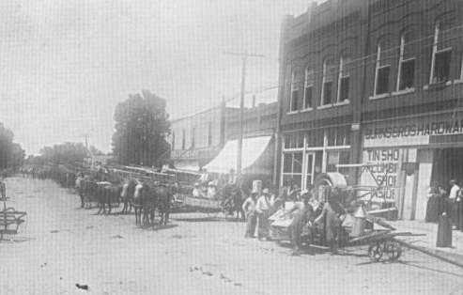

1900's scene on Paul Street in Pauls Valley
(http://okgenweb.net/~okgarvin/towns/pvhistory.htm)

Pauls Valley Beginnings experienced by Dr. Thomas P. Howell
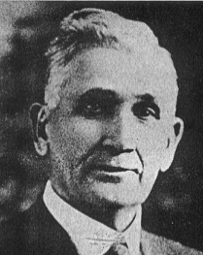In 1874 I came to Pauls Valley. It was then a cross-roads trading point. I was the only doctor at Pauls Valley at that time. Zack Gardner, a Choctaw Indian, had settled on the Washita river east of where Pauls Valley is now, shortly after the Civil War and was founder of the first grist mill there. It was a water power mill, the Washita river furnishing the power. Smith Paul was one of the first men to locate in this valley and Pauls Valley was named for him. Tom Waite, Zach Gardner, Jimmie Gardner and several others were large farmers and they had the contracts to sell their corn to the government at Fort Sill, for one dollar a bushel.
The life of a country doctor at that time was very hard in this newly settled country. Pauls Valley was just far enough from the Texas line to be a rendezvous for outlaws of every description. In the running fights between outlaws and pursuing officers and law-abiding citizens, many were wounded and the country doctor had to lend his assistance to the wounded of either party. There were so few doctors in this country that even the outlaws couldn't afford to be careless and use them for targets in their free-for-all shooting scrapes. There was little money in the country in those days. That was how I happened to start a ranch. I had to accept cattle as pay for professional services; it was a choice of cattle or nothing. I started my ranch a few miles east of Fort Arbuckle in 1876, on Wild Horse Creek. The two-room log house I had built still stands. I had it moved a short distance later and had the home I now live in put on the spot where the log house did stand. C.J. Grant and myself established the first bank in Pauls Valley. C.J. Grant, Noah Lael, Perry Froman and myself owned the first bank in Davis. Doctor Shirley owned a general store at Cherokee Town when I came to Pauls Valley.

(Excerpt from Indian Pioneer Paper Collection: Dr. Thomas Pitchlyn Howell, WPA Field Worker, Maurice R. Anderson Aug 30, 1937, Interview IDs 4255 & 8346: (https://digital.libraries.ou.edu/cdm/ref/collection/indianpp), photo (http://okgenweb.net)

Moman Pruiett on Pauls Valley

‘When Pruiett located at Pauls Valley that village was just a little wilder, a little woolier, and a little rougher than any stomping ground in the Chickasaw Nation or any other nation. It was in the period of the frontier west when a six-shooter acted as the town clock and the sexton of the cemetery was the most important officer. The saloons, or rather, the 'uno joints', never closed, and the merry din of the festive liquor glass and the rattle of the festive poker chip blended together into a weird music that only those who have known the early days in Oklahoma appreciated as music.” (Excerpt from "Moman Pruiett, Criminal Lawyer"), photo (Bing Images)
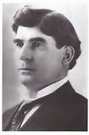
For more individual accounts of the early days of Pauls Valley see the Indian-Pioneer Interviews done by the Works Progress Administration in the mid-1930s. They can be found at the Western History Collection at the University of Oklahoma. (https://digital.libraries.ou.edu/cdm/landingpage/collection/indianpp)

Pauls Valley History
By the
Pauls Valley Historical Society
“The Queen of the Washita” as the City of Pauls Valley was once known was one of the earliest settlements in Indian Territory.

Smith Paul, born in 1809 in New Bern, North Carolina, lived with the Chickasaw Indians in Northwestern Mississippi for seventeen years. On a wagon train trip to California, Paul discovered the fertile bottom land which is now Pauls Valley. Paul described the land as “a section where the bottom land was rich and blue stem grass grew so high that a man on horseback was almost hidden in its foliage”.

The Tri-Party Treaty of January 1, 1837 ceded this fertile part of what is now the State of Oklahoma to the Chickasaw Nation. When the Chickasaw Indians were relocated to Indian Territory that year, Smith Paul moved with them. He then married Ela-Teecha, a Chickasaw Indian woman. In 1857, the Pauls settled on the rich Garvin County bottom land which became known to locals as Smith Paul’s Valley. The Santa Fe Railroad shortened the name to Paul’s Valley when the railroad came to town in 1887.

The railroad brought growth and prosperity to Smith Pauls Valley. The first newspaper was published in 1887. The Pauls Valley town site was laid out in 1892. A U.S. Court house was built in 1895. The first white school in Indian Territory was established and brick buildings were built downtown. In 1909, the streets were bricked. Today, Pauls Valley has more brick streets than any other town in the USA.

Early Pauls Valley People
(PV Historical Society http://paulsvalley.com/for-residents/organizations/historical-society)
1895 Petit Jurors of the first United States District Court
held at Pauls Valley
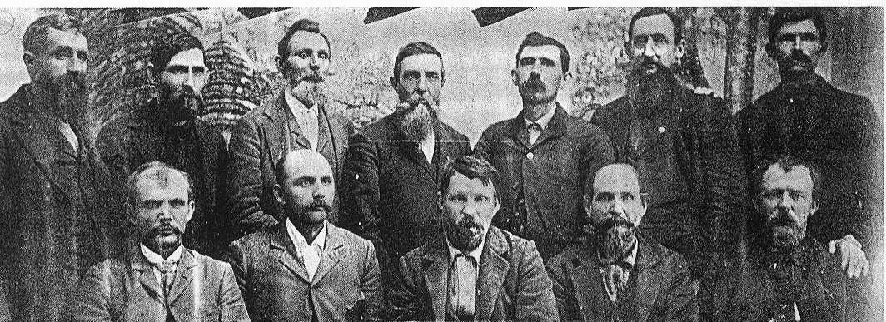
Petit Jurors of the first United States District Court held at Pauls Valley in 1895 were, back row from left: Dick Pruitt of Hickory Grove, J. M. Burch of Paoli, F.M. Boykin of Whitebead, W.C. Castleberry of Ada, Will Seymour of Pauls Valley, John Paddock of Wynnewood, and Will McCarry of McGee. Front row from left are J.W. Warlick of Whitebead, John Mentzer of Hickory Grove, George Manning of Pauls Valley, Sam Tatum of McGee and George P. Dickerson of Davis. (photo & text http://okgenweb.net)
Schools of Pauls Valley
(photos Bing Images)

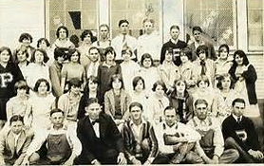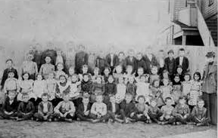

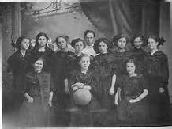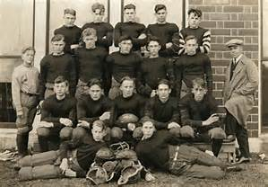
1911 Pauls Valley championship girls basketball team.
Back row L-R: Bernice Bush, Crickett Mundell, Mabel Terry,
Mytle Horne, Coach Walter Isle, Ada Saxon, Vivian Drake,
Amey Taylor and Jewell Patchell. Front row: unknown.
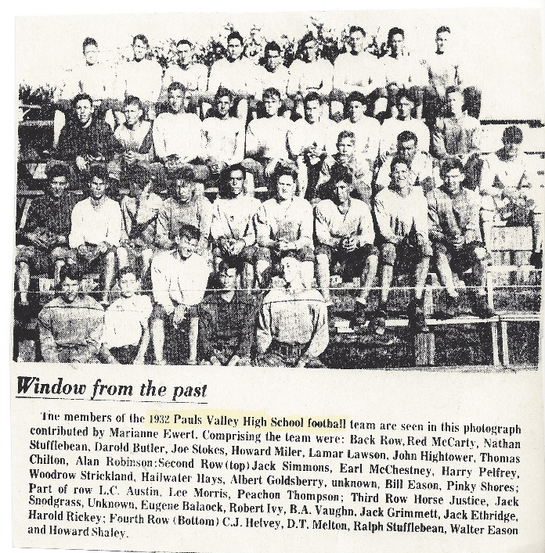

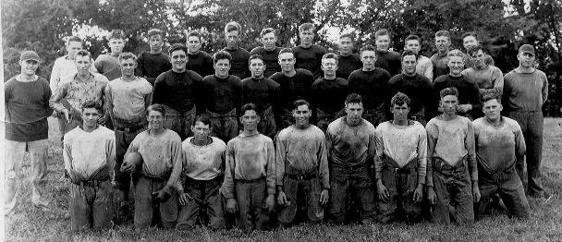
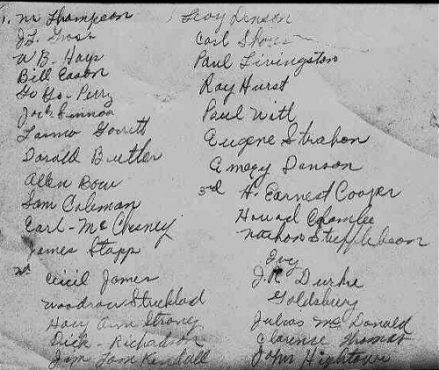
Around 1927-30
My father was Albert William Goldsbury (http://www.okgenweb.net/~photogallery/Schools/p)vfbteam1.html
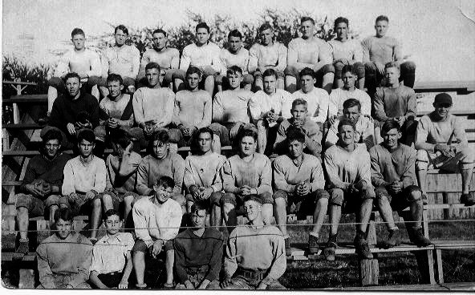
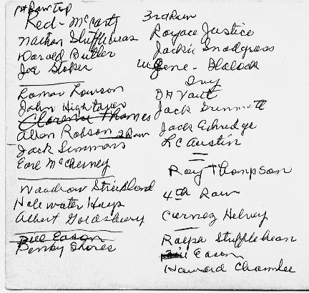
Contributed by Katie Goldsbury Horn

Businesses of Pauls Valley Early Days

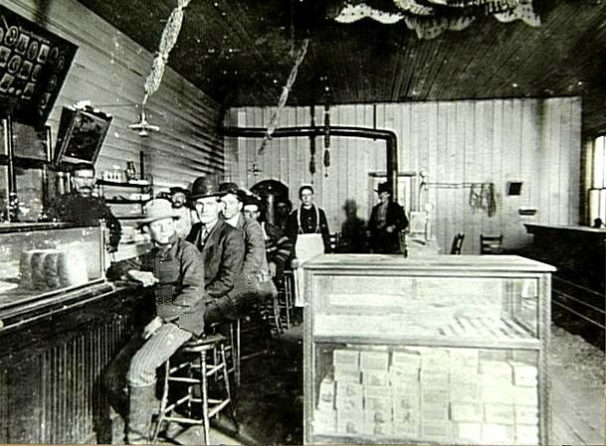
Montgomery's Restaurant
The young man in the front is Grover Cleveland Carroll, born 18 Aug 1885. You can guess how old he is in the photo. I thought he would be older than 15. In 1900, the family was listed in the Chickasaw Nation Fed. Census so the photo would have to be after that date? All the information on the back of the photo was: Cleve Carroll, Montgomery's Restaurant, Pauls Valley, Ok. Submitted by: Charles E. Carroll (okgenweb.net)
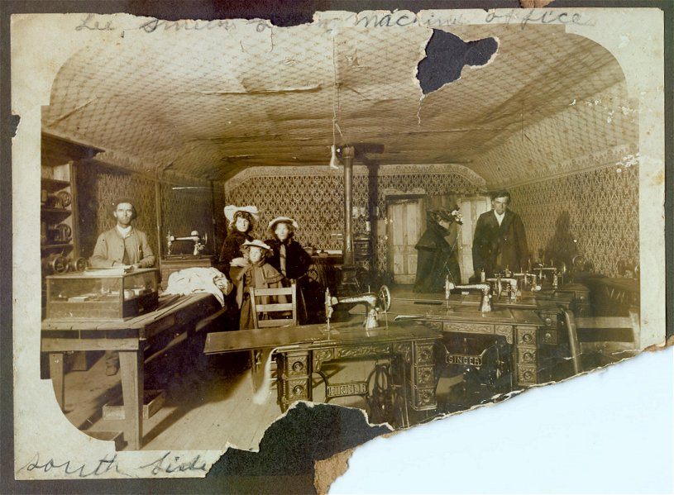 (http://okgenweb.net)
Here is a photo of my grandfather Leroy Preston Smith taken in PV 1900-1901. Leroy is on the left behind the counter. Others are not known to me. He married my grandmother 4 June 1901. She had come to IT in 1898. I have yet to determine exactly when Leroy arrived. They were married by her father John Hadden Ivy who was a minister. The Smiths move to Coalgate before August of 1902.
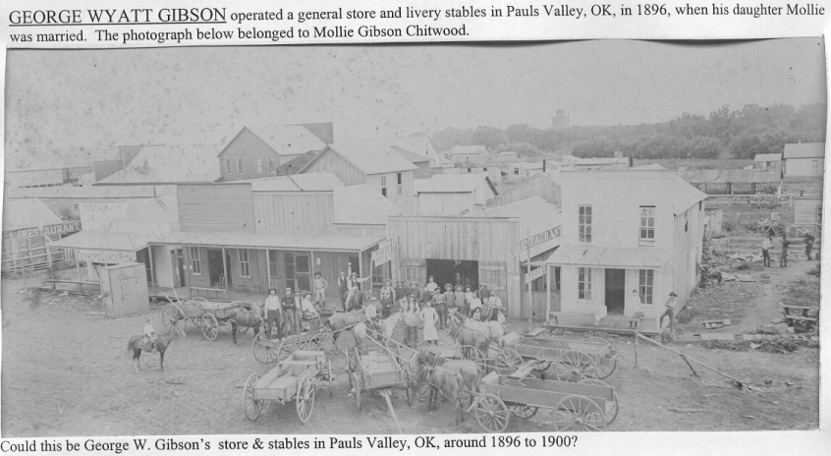
(http://okgenweb.net)

(text & photo http://okgenweb.net)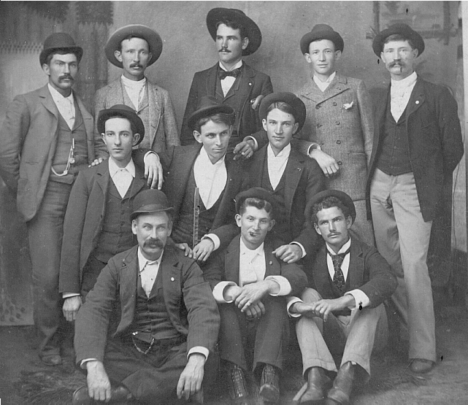Submitted by Carolyn Fairall
George Wyatt Gibson operated a general store and livery stables in Pauls Valley, OK, in 1896, when his daughter Mollie was married. The 1st photograph (possibly of scene from early Pauls Valley) to follow in attachment, belonged to Mollie Gibson Chitwood. The 2nd photograph is of G. W. Gibson & possibly sons and other relatives. (from collection of my grandmother, Mollie Gibson Chitwood).
George Wyatt Gibson (front row far left), three sons-in-law, and three nephews have been identified. The occasion for this photo was probably the 1901 wedding of his nephew Wesley Oliver Henderson (center). The four sons of George Wyatt Gibson living in Pauls Valley, OK in 1900 were: William Dennis (Dick) – liveryman John Warren – iceman Edgar – blacksmith, Louis – salesman.
The three sons-in-law living in Pauls Valley in 1900, are: Charles Richard Chitwood - worked in store (top row far left) Oliver Watson Bandy - blacksmith (top row second from left) Thomas G. Bandy - blacksmith (top row far right). Other relatives (the 3 in middle row, L to R) are: Arthur Howard Henderson, b 1881 AR, d 1941 AR George Chester Henderson, b 1876 AR, d 1935 OK Wesley Oliver Henderson, b 1879 AR, d OK All three are nephews of George Wyatt Gibson.

Pauls Valley Business Section 1890’s
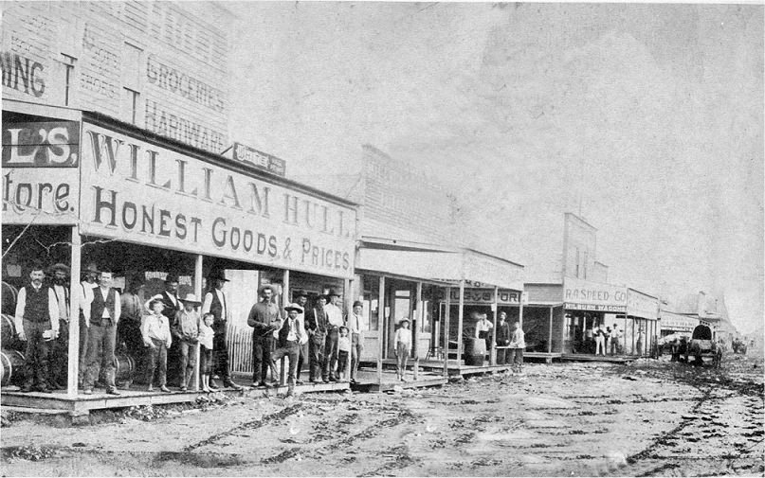At this time the business section of Pauls Valley was confined to a row of buildings fronting the railroad. Merchant William Hull was a wealthy intermarried Indian Citizen. Farther up the street is the store of R. A. Sneed. Col. Sneed was a Confederate Veteran who was to become Oklahoma's first secretary of state and later superintendent of Platt National Park. Mr. Hull built a fine home northwest of Pauls Valley in a community that bore his name, Hull Bend. Next to the Hull store is the drug store of Dr. W.J. Miller and the post office. Buck Paul was then postmaster. Other businesses were the clothing store of Smith Bradley and the Gus Whiting store. The old Gordy Hotel was directly north of the Hull store. (http://okgenweb.net)

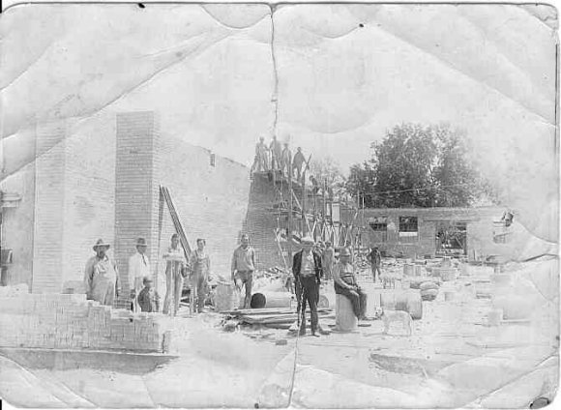
This picture was taken in the early 1900s. I think it was taken in Garvin County. I am trying to see if anyone can identify where it was taken and what year. I know my father helped to build the Garvin County Courthouse, but someone thinks this may be a bank building (possibly at Wilson) or some other public building. My father is in the picture, but I do not know the others.
Name #1 Tensley Eli COX, SR. standing in the background, in light colored overalls and hat, between the man in the dark pants and sweater and cap and the man sitting on the barrel in the foreground. Submitted by: Dorothy Cox Smith, E. (http://www.okgenweb.net/~photogallery/Snapshots/garvinco.htm)

Families of Pauls Valley
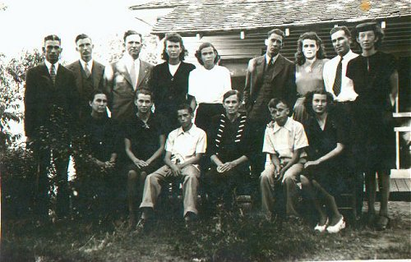
Dolly Mae Malicoat b 10-27-1893 Indian Territory, d 12-30-1964 Pauls Valley, Garvin Co., OK bur: Antioch Cem. md B. W. Beddo 7-03-1910 Indian Territory, he was born 12-01-1881, d. 6-12-1947Garvin Co., OK buried Antioch Cem. Picture is of Dolly Mae Malicoat Beddo and children taken 6-14-1947. Contributed by Jean Brand (http://www.okgenweb.net/~photogallery/Pion eers/dmmbeddo.html)
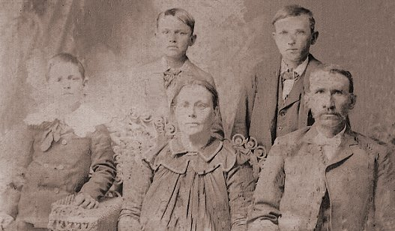
Taken 1901 in Pauls Valley, Oklahoma
Photo of my grand father and grandmother. The children are my father's brothers. My grandmother was pregnant with my father at the time of this photo. From left to right, back row: John Oscar Gray James Rufus Gray Owen Gray. Front row, left to right: Addie Jane (Nelms) Gray Rufus L Gray Contributed by: graywolf49@aol.com (http://www.okgenweb.net/~photogallery/Pioneers/grayfam5.html)

German Prisoners of War Camp
July 1944-1945

Estelle Readnour
(transcribed 1/17/2017: no corrections)

“The Camp was located behind the N. Y. A. building where the National Guard property is now. All the way to the football field for many years, before the new field was built. The area was well fenced with strong hog wire and barbwire approximately 200 prisoners.

The N. Y. A. building was built in the 30’s {1930’s]. It was used by the Doctors, as office and also, sick bays. Other personnel had offices there. They kept the area around very clean.

The prisoners arrived in Aug. 1944 and moved out soon after the end of war, August 14, 1945. The information I received was that the majority of them was from Rommel’s army from Africa. There were lots and lots of tents. The men were allowed to help farmers in their area. Farmers had Government rules to go by-overseeing and transportation.

There were a few horses inside that they used to play Polo on. They also, planed socor a lot of course that’s one of their choice games. No one in the neighborhood seemed to be disturbed about the camp. They felt safe, as they knew the guards were there.

My grandparents, John W. and Lorinda Jane Darnell, owned a home directly across the street from the middle part of the camp. My brothers, Odell Sterling, Bonnie Belle Sterling and I were raised here-almost through high school. After our grandparents passed away we went back to Wynnewood, where we made our homes. Our Mother and her sis and husband, Mr. and Mrs. John Scally moved into the house.

The doctors and other personnel became acquainted with the family, and dropped in often-for a free meal, homecooked cake and cookies. The two ladies were happy to serve them home cooking, as they were away from home.

We came up pretty often to visit our family. When the men in camp saw our little 4-5-year-old boy playing the in the yard, three or four would come to the fence and want to talk to him. They would reach through the fence and pat him on the head-one gave him a bar of candy. He always remembers that. I’m sure he reminded some of them about theirs. It seemed to cheer them up. They were very nice as far as our association went.

Broom corn was one of the top crops in this area. Lindsay was known as “The Broom Corn Capitol of the World.” Their slogan was “Lindsay Broom Corn Sweeps the World.” Help was scarce as so many men had gone to war. The help from the camp was certainly a great help. Kenneth Coffey, Pauls Valley, had a broom corn thrasher and used some of the prisoners. W. J. Loman, Pauls Valley, also, worked some of them.

Their statements to me about the help: ‘normal help-some good and some bad.’

p.s. It was located in area of National Guard builing and to the north east. It was behind NYA builidng and insoftball park a rea in Wacker Park in Pauls Valley. The prisoners did farm work in this area for farmers who would come and get them and teake them to their farms. Thye were paid a little for their servics and glad to get away frm the camp and would work. They wre treated good while they were here.

German Prisoner of War Camp Pauls Valley

